In loving memory of

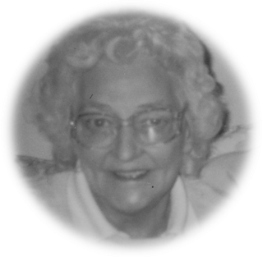

Hazel Ruth Elwell

16th February 1928 – 27th April 2013

Thursday 9th May 2013

Fox Covert

Order of Service

Introduction

All: Merciful Father, hear our prayers and comfort us; renew our trust in your Son, whom you raised from the dead; strengthen our faith that all who have died in the love of Christ will share in his resurrection; who lives and reigns with you, in the unity of the Holy Spirit, one God, now and for ever. Amen

Psalm 23:

1 The Lord is my shepherd; therefore can I lack nothing.

2 He makes me lie down in green pastures
and leads me beside still waters.

3 He shall refresh my soul and guide me
in the paths of righteousness for his name’s sake.

4 Though I walk through the valley of the shadow of death,
I will fear no evil;
for you are with me; your rod and your staff, they comfort me.

5 You spread a table before me
in the presence of those who trouble me;
you have anointed my head with oil and my cup shall be full.

6 Surely goodness and loving mercy
shall follow me all the days of my life,
and I will dwell in the house of the Lord for ever.

Glory be to the Father, and to the Son,
and to the Holy Spirit:
As it was in the beginning, is now, and ever shall be:
world without end. Amen.

The Scriptural Reading: 1 Peter 1. 3-9

The Eulogy

The Prayers and Lord’s Prayer:

Each section concludes:
Lord, in your mercy
All: hear our prayer.

After the final section:
God of mercy, entrusting into your hands all that you have made and rejoicing in our communion with all your faithful people, we make our prayers through Jesus Christ our Saviour. Amen.

All: Our Father, who art in heaven, hallowed be thy name; thy kingdom come; thy will be done; on earth as it is in heaven. Give us this day our daily bread. And forgive us our trespasses, as we forgive those who trespass against us. And lead us not into temptation; but deliver us from evil. For thine is the kingdom, the power and the glory, for ever and ever. Amen.

The Commendation and Committal:

God our creator and redeemer, by your power Christ conquered death and entered into glory. Confident of his victory and claiming his promises, we entrust N to your mercy in the name of Jesus our Lord, who died and is alive and reigns with you, now and for ever. Amen

The coffin is interred as the words of Committal are read

A prayer for each other and for ourselves is followed by the Blessing.

                        

